**Ali Abbas Khan**

**24-CP-27**

**PF Lab No 4**

**Date 03-02-2025**

**Obtain Marks =8**

**Task 01**

**Question No. 01**

Write a program to check whether an integer entered by the user is positive or negative using simple if statement

**Coding and result**

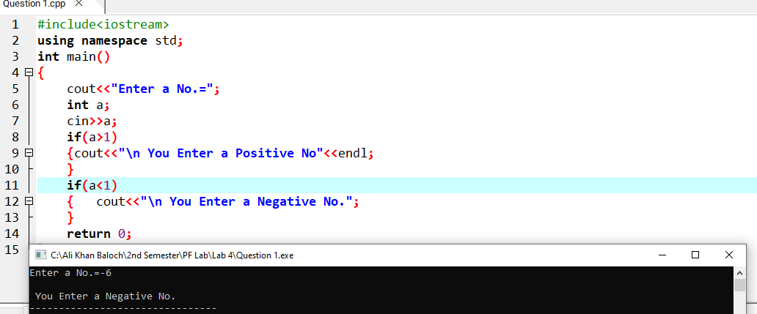

**Question No. 02**

program will perform multiplication and display the result and so on. program will add two numbers and will display the result and if the operator is ‘*’ then the Program will perform arithmetic operation based on operator i.e., if the operator is ‘+’ then Write a program that prompts the user to enter two numbers and an operator (+,-,*,/,%)

**Coding and result**

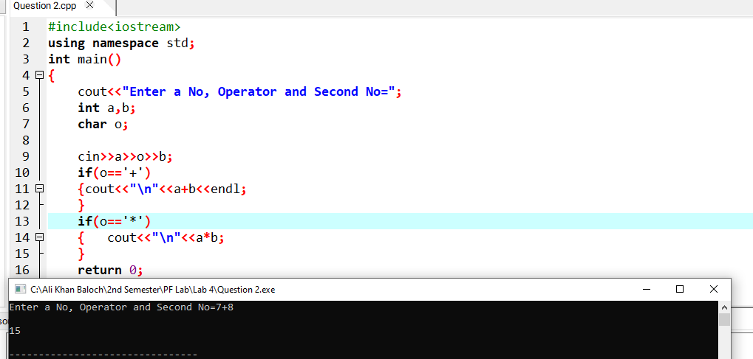

**Question No. 03**

display output messages according to the value of discriminant. the equation has two complex roots".The program takes values of a, b, and c as input and the equation has two real roots". If the value of the discriminant is negative,then display " display" the equation has a single real root". If the value of the discriminant is positive,then" b^2−4ac determines the nature of roots. If the value of the discriminant is zero, then Write a C++ program that solves the equation to find its roots.The value of the discriminant

**Coding and result**

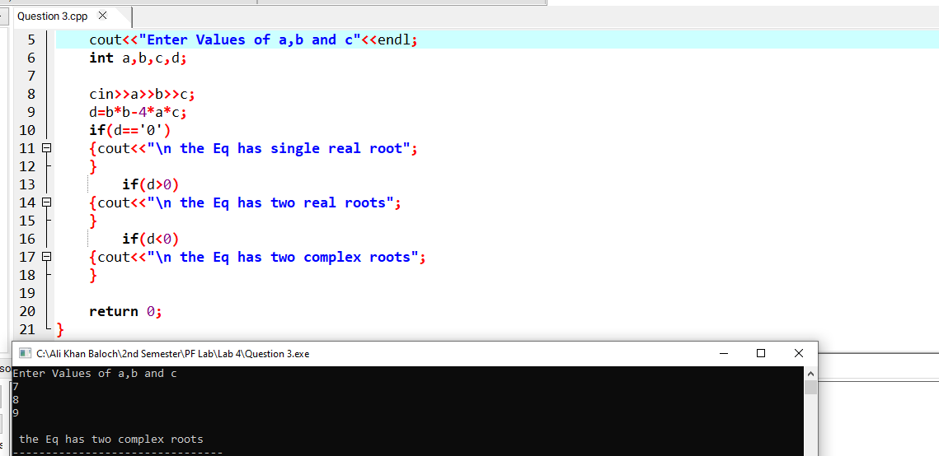

**Question No. 04**

Calculate Net pay by adding basic pay, medical allowance, conveyance allowance and house rent. than 50,000. λ Conveyance allowance is RS-5000 if Basic pay is less than 50,000.It is 8000 if the basic pay is more less than 50,000. λ Medical allowance is 2% of the basic pay,if basic is greater than 50,000.It is 5% of basic if pay is House rent is 45% of the basic pay. as follows: Write a program to calculate the net pay of an employee.Input the basic pay and calculate the net pay

**Coding and result**

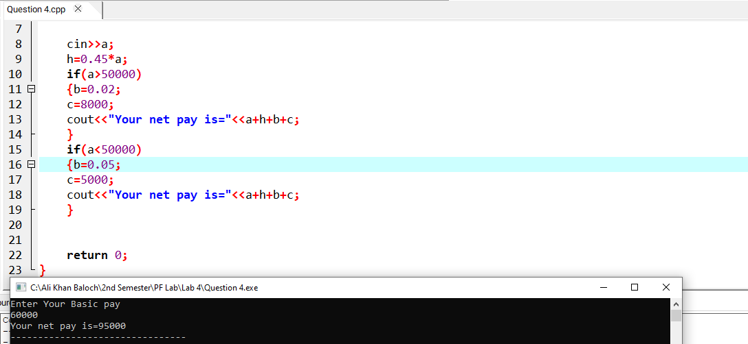

**Question No. 05**

Write a program to input two integers and then to find out whether these numbers are equal or different.

**Coding and result**

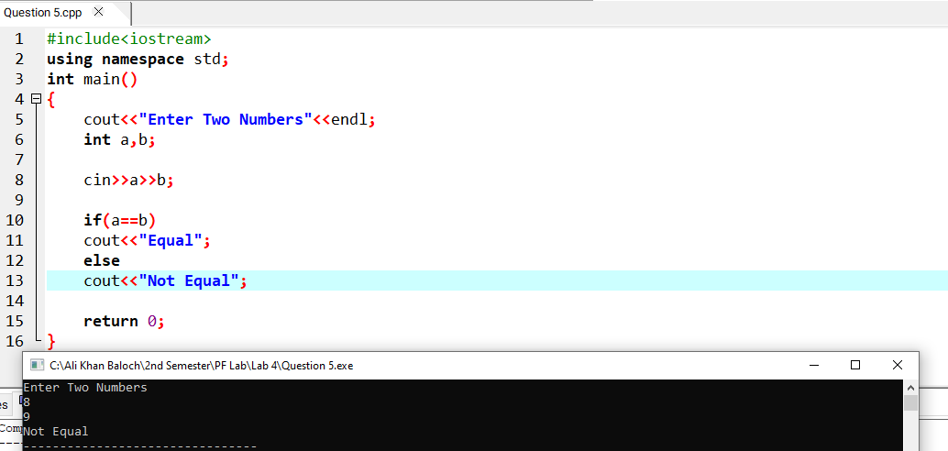

**Question No. 06**

4.~(3 & 3 & 14) 3. ((5 > 7) * 10) && ( 5 * 2 ) 2. 7 + 7 == 70 / 5 * 1 + 25 % 5 1. 10. 6 + 17 % 3 - 2 a. First, solve by hand and then program these expressions and see output on screen? Observe output of following:

**Coding and result**

**Question No. 07**

Write a program to input a number from keyboard. Use if-else statement to find out whether the number is less than or greater than 100.

**Coding and result**

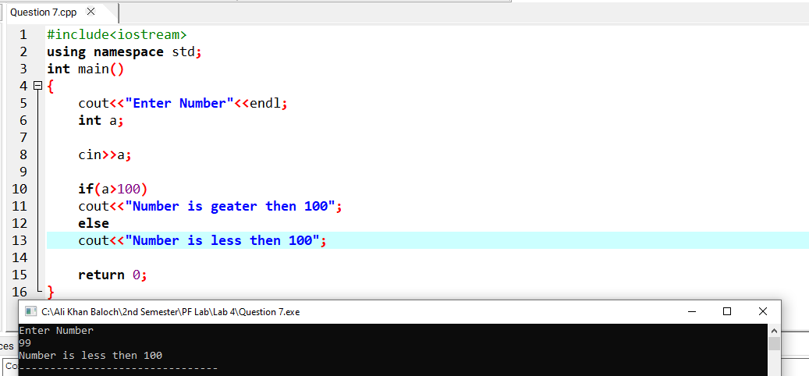

**Question No. 08**

Write a program to prompt the user to enter an alphabet and then tell whether the entered character is vowel or consonant.

**Coding and result**

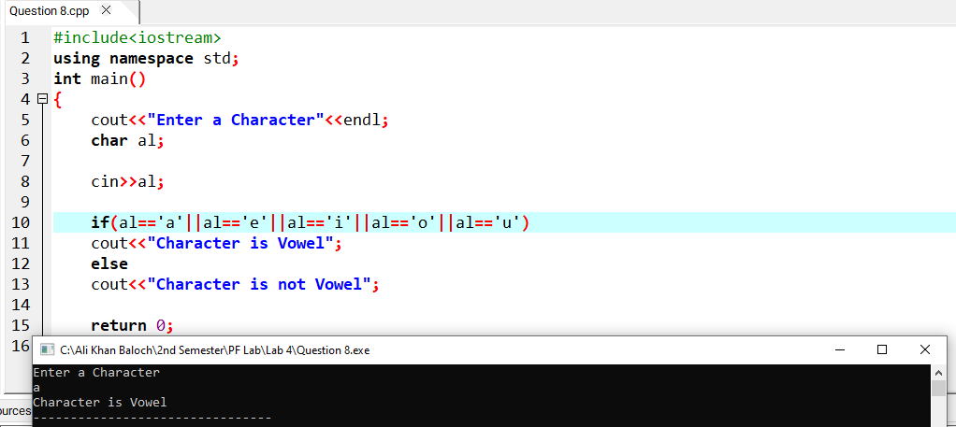

**Question No. 09**

**Coding and result**

